RFC: New HDF5 API routines for HPC Applications
Peter Cao
Quincey Koziol
Jonathan Kim
Mohamad Chaarawi
The HDF5 library allows a data access operation to access one dataset at a time, whether access is collective or independent. Accessing multiple datasets will require the user issuing an I/O call for each dataset. This RFC proposes new routines to allow users to access data in multiple datasets with one I/O call.
This RFC describes the new API routines, H5Dread_multi() and H5Dwrite_multi(), which perform a single access operation to multiple datasets in the file. The new routines can improve performance, especially in cases when data accessed across several datasets from all processes can be aggregated in the HDF5 or MPI-I/O library.

Introduction
Parallel HDF5 (PHDF5) supports both independent and collective dataset access. When collective I/O is used, all processes that have opened the dataset may do collective data access by calling H5Dread() or H5Dwrite() on the dataset with the transfer property set for collective access. Accessing dataset collectively by using the MPIO VFD can improve I/O performance, ^{[1]} since data can be aggregated by MPI into large contiguous accesses to disk instead of small non-contiguous ones.
However the current HDF5 library does not support a single I/O call for multiple datasets. For example, if you access five datasets in a file, you will need at least five I/O calls.
We propose to add three new functions to the HDF5 library: H5Dread_multi(), H5Dwrite_multi() and H5Dclose_multi(). Using the proposed new read/write functions, users will be able to make a single function call to read or write data to multiple datasets. The new functions can be used for both independent and collective I/O access, but our discussion below will focus on the collective case.

Use Cases

Improving FLASH I/O
FLASH code was designed to simulate thermonuclear flashes on a Cartesian, structured mesh. The mesh consists of cells that contain physical quantities such as density, pressure and temperature (also known as mesh variables). Each cell is assigned to a self-contained block. In the FLASH file layout, a block is stored in an HDF5 file and mesh variables are stored as 4D datasets in the file.
In a FLASH simulation, the time spent on file I/O is a common bottleneck. Using collective I/O^{[1]} improves I/O performance for HPC applications like FLASH. Current parallel HDF5 performs collective I/O on a single dataset and requires many I/O calls in FLASH simulations since there are frequently many variables accessed during each time step. Using the proposed collective I/O on multiple datasets will reduce the number of I/O calls. In an experimental study, Rob Latham, Chris Daley, etc.^{[2]} have showed that the average time for writing a file is reduced by half when collective I/O on multiple variables is used:
“The standard file layout approach (storing application data in multiple library objects), however, offers a slight performance trade-off. Each function call represents a relatively expensive I/O operation. All other factors aside, if the goal is to achieve the highest I/O performance a better approach would describe the entire application I/O pattern and then execute a single call. If the application places all mesh variables into a single I/O library object, as in the experimental file layout approach, then a single I/O library call could be issued to service all application variables instead of N separate calls. Experiments confirm that this approach does improve performance.”^{[2]}

Implementation
The basic approach for multi-dataset collective I/O is similar to the POSIX lio_listio() call, which takes a list of buffers, offsets and lengths to perform read and write operations on a file. The major difference from the typical HDF5 API call is that the new routines add information from multiple datasets to the I/O mapping list and construct larger MPI derived datatypes for collective I/O operations. Internally, the multi-dataset implementation will be similar to the current implementation of collective chunk I/O on a single dataset.
The following example chart shows the conceptual implementation approach for the new API functions

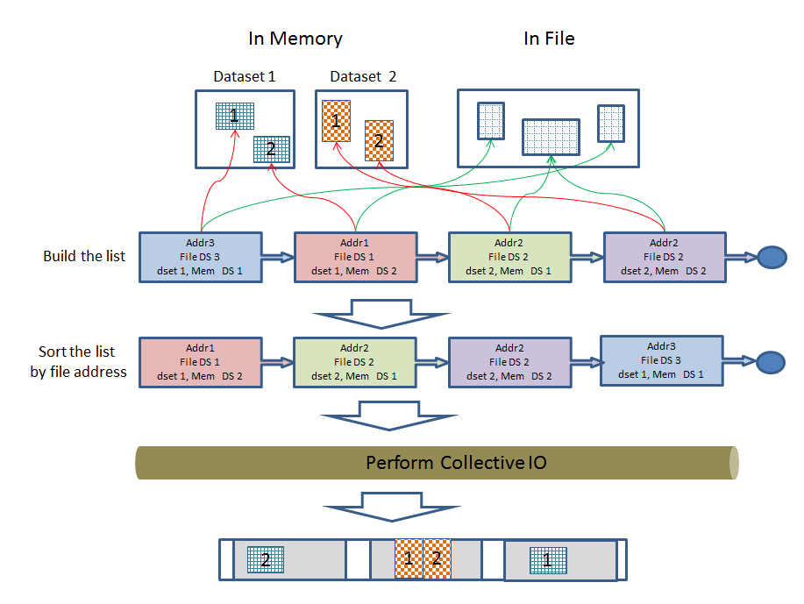

Note that soring the list by file addresses is necessary because MPI requires the filetype to consist of derived datatypes whose displacements are monotonically non-decreasing

New API Functions
Three new functions, H5Dread_multi(), H5Dwrite_multi() and H5Dclose_multi() are proposed here, and a common type structure is used for the APIs as defined below:
typedef struct H5D_rw_multi_t
{
hid_t dataset_id;
hid_t file_space_id;
void * buf; /* data buffer */
hid_t mem_type_id;
hid_t mem_space_id;
unsigned int close_flags; /* handle close/free resources */
} H5D_rw_multi_t;

H5Dread_multi()
This routine performs collective or independent I/O reads from multiple datasets. In collective mode, all members of the communicator associated with the HDF5 file must participate in the call. Each process creates the information required to perform each read in the array of H5D_rw_multi_t structures, and passes the array through to H5Dread_multi().

The API function description is as shown below.
herr_t H5Dread_multi(hid_t file_id,
size_t count,
struct H5D_rw_multi_t info[],
hid_t dxpl_id);
Parameters:
- file_id: file or group id for the location of datasets
- count: the number of datasets.
- Info: the array of dataset information and read buffers.
- dxpl_id: dataset transfer property.
Return:
- a non-negative value if successful; otherwise returns a negative value.

Brief description is as follows. Note that details have been omitted for brevity.
- Each process obtains the list of dataset info from the info[] array structure, and constructs a derived MPI datatype describing the sections of the HDF5 file to be read.
- All processes call MPI_File_read_at_all() once for collective I/O or MPI_File_read_at() once for independent I/O.
- Each process tidies up, and then returns with the desired data in the buffers pointed to by the buf fields of the elements of the info[] array structure.

When the application issues a collective read call, the H5D_rw_multi_t array does not have to be identical across all processes that are participating in the collective operation. This means that not only the actual data in the buffers can be distinct (like most collective I/O operations), but the dataset (and dataspaces, datatypes, etc…) values for every process can be distinct.
For example, consider the following:
- Rank 0 process reads from Datasets A, B, and C.
- Rank 1 process reads from Datasets C and D.
- Rank 2 process does not read anything.
All processes will call the read operation with a different count and H5D_rw_multi_t array. Process with rank 2 will actually pass NULL value for the array struct, because it does not wish to read anything. All processes are required to pass the same file_id and the same property values for the dxpl_id. The same rule applies to H5Dwrite_multi() that is detailed in the following section.

H5Dwrite_multi()
This routine performs collective or independent I/O writes to multiple datasets. In collective mode, all members of the communicator associated with the HDF5 file must participate in the call. Each process creates the information required to perform each write in the array of H5D_rw_multi_t structures, and passes the array through to H5Dwrite_multi().

The API function description is as shown below.
herr_t H5Dwrite_multi(hid_t file_id,
size_t count,
struct H5D_rw_multi_t info[],
hid_t dxpl_id);
Parameters:
- file_id: file or group id for the location of datasets
- count: the number of datasets.
- Info: the array of dataset information and write buffers.
- dxpl_id: dataset transfer property.
Returns:
- a non-negative value if successful; otherwise returns a negative value.

Brief description is as follows. Note that details have been omitted for brevity.
- Each process obtains the list of dataset info from the info[] array structure, and constructs a derived MPI type describing the sections of the HDF5 file to be written.
- All processes call MPI_File_read_at_all() once for collective I/O or MPI_File_read_at() once for independent I/O.

H5Dclose_multi()
This routine performs close and frees resources used by H5Dread_multi() or H5Dwrite_multi() APIs.
A user can also close or free resources that are used by H5Dread_multi() or H5Dwrite_multi() manually. Thus, this routine is an optional to be used. This routine is added mainly to provide convenience for user.

The API function description is as shown below.
herr_t H5Dclose_multi(size_t count,
H5D_rw_multi_t info[]);

Parameters:
- count: the number of datasets.
- Info: the array of dataset information.
Returns:
- a non-negative value if successful; otherwise returns a negative value.

A user can set below values as bitwise to ‘close_flags’ which is a member variable of H5D_rw_multi_t struct. This close function will perform close ids and free buffer accordingly.

H5D_MULTI_CLOSE_ALL (0x0000u) /* close and free all, Default */
H5D_MULTI_CLOSE_DATASET (0x0001u) /* close dataset only */
H5D_MULTI_CLOSE_MSPACE (0x0002u) /* close mem space only */
H5D_MULTI_CLOSE_FSPACE (0x0004u) /* close file space only */
H5D_MULTI_CLOSE_DATATYPE (0x0008u) /* close datatype only */
H5D_MULTI_FREE_BUF (0x0010u) /* free data buffer only */

[1] Yang M and Koziol Q, 2006. Using collective IO inside a high performance IO software package—HDF5 Technical Report National Center of Supercomputing Applications
[2] Rob Latham, Chris Daley, etc., March 2012. A case study for scientific I/O: improving the FLASH astrophysics code, http://iopscience.iop.org/1749-4699/5/1/015001/article

Revision History

August 28, 2012: | Version 1 by Peter Cao. Circulated internally.
Sep 27, 2012: | Version 2: updated based on internal reviews.
Feb 15, 2013: | Version 3: Updated based on internal reviews. Revised APIs and related contents.  (HDFFV-8313)

