RFC: Supporting Dimension Scales in HDFView

04/29/2013
Peter Cao
The HDF Group

Introduction
Supporting dimension scales has been requested by our NASA users and other general HDF users. It is also one of the major tasks from the 2012 NASA briefing. The feature was repeatedly mentioned in the HDFView user’s survey also as shown below.
Survey response #14
Supporting dimension scales would be huge for us, especially the ability to open data sets with dimension scales as images and then display them either by pixel (current approach), or by physical mapping according to the dimension scale (e.g. the image would be scaled linearly or logarithmically by the dimension scale)... I understand that this could be non-trivial to implement and potentially compute intensive, because this would require some sort of interpolation from the computational grid/pixels onto the physically scaled image (according to the dimension scales). While this feature might be considered more of a vis package feature to some, it would be huge productivity boon for us to be able to more quickly explore our very large simulation data--before moving our workflow into a more serious vis program such as Paraview, VisIt, or Tecplot. As a first approach, just providing axes with the image would be a decent first cut. Many thanks for working on such great tools: The HDF5 tools and data storage approach has revolutionized the way we deal with very large direct numerical simulations of compressible and hypersonic turbulence. It enables us to perform IO more efficiently and reduce confusion and errors about the context and content of our scientific data sets while improving portability between different machines, and demolishing barriers to collaboration and data sharing. 11/3/2011 11:49 AM
NASA users have repeatedly requested relevant features such as adding Dimension Scale (DS) and linking DS to target dataset. This RFC is to investigate what is needed to support DS in HDFView.

HDF5 Dimension Scale (DS) Specification
The HDF5 Dimension Scale (DS) Specification version 1.0 ^{[1]} was published in 2005. The HDF Group also provided a set of high level C API functions for the HDF5 Dimension Scales (H5DS) ^{[2]}. The HDF DS specification and programming API provide relevant information about a dataset’s dataspace. The challenge to use the HDF5 DS in applications, such as in HDFView, lies on interpreting the meaning of the DS. Since the meaning is application-specific, it will be impossible for a general HDF5 tool like HDFView to give a one-size-fits-all solution. The goal of this RFC is to identify what HDFView can do based on the current HDF5 DS specification and programming API.

Limitation
- This RFC will only focus on HDF5 DS. Since there is no DS specification for HDF4, we will leave it out from this work.
- The proposed work will follow the HDF5 DS programming model. Many application-specific features will not be included.

Requirements
We are not going to give a list of general software requirements in this document. We only give a few things that are specific to DS.
- There should be no change to the current HDF-Java programming model. Since external plugin-ins depend on the current HDF-Java model, changes to the current API functions may break user’s application. New functions may be added to support features related to DS but no change to the existing functions
- Showing DS or not should be configurable. Users can choose to use DS or not in HDFView.

The feature set
Features of supporting DS in HDFView include creating DS, linking DS to target dataset, and showing DS in TableViewer and ImageViewer.

Creating DS in HDFView
HDFView will allow users to create a dataset of dimension scales. The way of creating a DS dataset may not have much difference from creating a normal dataset because details of adding the standard attributes to a DS dataset are transparent to users. Before a DS dataset is committed to the file, the DS dataset will be verified and conformed to the HDF5 DS specification.

Linking and unlinking DS (association of DS datasets and datasets)
Users will be able to link and unlink a DS dataset to a target dataset. The way of connecting a DS dataset with the target dataset is same as an image palette to an image, i.e. using attributes of references.

Showing DS in TableView/ImageViewer
Options to use DS or not will be provided. HDFView will use a simple one-to-one mapping of dimension index to DS value. It will not support any math manipulation or interpolation (e.g., logarithm).
Two special cases when a DS and its target dataset have different dimension sizes:
- The DS length is larger than the dataset dimension size: values of DS will be truncated according to the size of dataset dimension
- The DS length is less than the dataset dimension size: the value beyond the DS size will be left as blank
The following is a mockup example of TableView and ImageViewer with DS.
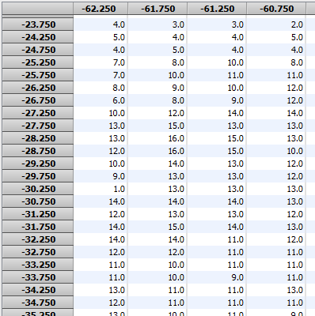 | 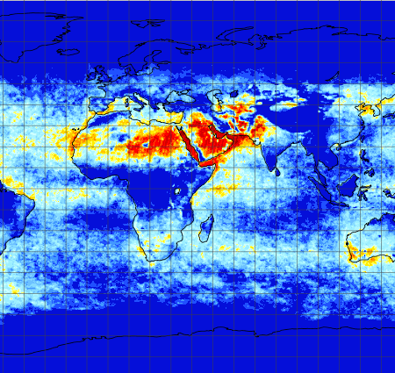

The task break-down and work estimation
The total work is 120 hours based on our first estimation.

(40 hours) Implementing H5DS JNI functions
The HDF5 Dimension Scale API functions (10) will be added to HDF5 JNI.
For details of the API, see http://www.hdfgroup.org/HDF5/doc/HL/RM_H5DS.html
Work estimation: 40 hours (10 functions x (2 hours implementation + 2 hours testing))

(18 hours) Implementing GUI components to add DS
- Adding new GUI components: 8 hours
- Modifying objects to support DS: 2 hours
- Testing: 8 hours

(18 hours) Adding GUI components to link DS and target dataset
- Adding new GUI components: 8 hours
- Modifying objects to support DS: 2 hours
- Testing: 8 hours

(16 hours) Adding DS to TableViewer
- Showing DS labels: 4 hours
- Show DS values: 4 hours
- Testing: 8 hours

(20 hours) Adding DS to ImageViewer
- Showing DS labels: 4 hours
- Showing DS grid: 4 hours
- Show DS values for mouse move over: 4 hours
- Testing: 8 hours

(8 hours) Updating user’s guide

References
[1] HDF5 Dimension Scale Specification and Design Notes http://www.hdfgroup.org/HDF5/doc/HL/H5DS_Spec.pdf
[2] H5DS: HDF5 Dimension Scales
http://www.hdfgroup.org/HDF5/doc/HL/RM_H5DS.html

