Annual Report on HDF Java Tools
Peter X. Cao
April 2005

This is a brief annual summary of the HDF Java Tool work

1. The HDFView
There are two releases of HDFView since April 2004: HDFView 2.1 and HDFView 2.2.

HDFView 2.1 was released on September 2004. The HDF4 and HDF5 JNI for this release were built on HDF 4.2.0 and HDF5 1.6.3 respectively. This release fixed bugs from version 2.0 and added a few new features. The following is a list of major changes.
- Seamless plugin for user modules. HDFView will automatically detects and load user's GUI and I/O modules. No need to register new modules.
- Open remote files with URL such as http://hdf.ncsa.uiuc.edu/hdf-java-html/hdf5_test.h5,
ftp://ftp.ncsa.uiuc.edu/HDF/files/hdf5/hdf-java/hdf5_test.h5
- Add "HelpView" interface. Users can implement their own help view.
- Quick view of metadata.
- Create empty HDF5 compound dataset.
- Add and modify user blocks.
HDFView 2.2 was released on March 2005. The HDF4 and HDF5 JNI for this release were built on HDF 4.2.1 and HDF5 1.6.4 respectively. Major changes in this release include:
- Modify JNI for changes of HDF4 and HDF5 libraries.
- Bug fixes
- View variable-length datasets (in compound or nested compound)
- View ENUM dataset
- View compound/variable-length attributes
- Show indicator of attributes (objects with attribute attached)
- Slider bar for modifying image threshold range

2. HDF-EOS Module for HDFView
1) Help for the transition of the HDF-EOS module work from Ray Milburn to Dave Buto
2) Worked with Dave Buto to successfully plug HDF-EOS module into HDFView
3) Help for the transition of the HDF-EOS module work from Dave Buto to Abe Taaheri
4) Not much work done since October 2004.
5) To do: release issue. Have to check with Abe how should we release the HDF-EOS plug-in

3. HDF Web Plugin

1) HDF Web-browser plugin is a windowed browser plugin that is launched from a web browser to display HDF4 and HDF5 files. A browser plugin is a software program that extends the power of Web browser by adding more features and supporting more types of content than what the standard browser provides

2) Did some research on browser pluing technology and implementation options for HDF browser plug-in. For details, read “Report on HDF Browser Plug-in Project” at
http://hdf.ncsa.uiuc.edu/plugins/UsersGuide/TechReport/index.html

3) Release HDF Web-browser plugin 1.0.2 on October 2004
The HDFPlugin 1.0.2 is Windows only application. It is implemented as an active document servers. An active document server such as Microsoft Office Binder or Internet Explorer hosts documents of other application types called Active documents. An active document is a COM (Component Object Model) component that shows some data (charts, sheets, text documents, bitmaps) which is given by Active Document Server.

The HDFPlugin 1.0.2 supports both HDF4 and HDF5. It has most of the browsing features of the HDFView. However, it is a read-only tool. It does not have any editing features. For more details and download information, visit, http://hdf.ncsa.uiuc.edu/plugins/index.html

4. HDF5-SRB Project

4.1 Project description
The HDF format and the Storage Resource Broker (SRB) offer valuable and complementary data management services, and but they have yet to be integrated in an effective way. Early work has had the SRB access HDF either (a) by extracting entire HDF files, or (b) by extracting byte-streams through the SRB’s POSIX interface. Approach (a) fails to take advantage of HDF’s ability to offer interactive and efficient access to complex collections of objects. Approach (b) has been shown to be far too low-level to perform reasonably for some data extraction operations.
In discussions between NCSA and SDSC, it has been determined that a more effective approach is possible, one that uses the SRB as middleware to transfer data between the server and client. This approach would insert the HDF library and other object-level HDF-based libraries (such as HDF-EOS) between the SRB and a data storage source (such as a file system), making it possible to extract objects, rather than files or byte streams. Furthermore, these libraries typically offer query, subsetting, sub-sampling, and other object-level operations, so that these services might also be available. We propose to investigate implementation of object-level access to HDF-based collections that are stored in the SRB. By “object level” we mean access to individual datasets and groups, composite objects (e.g. HDF-EOS swaths), and subsets of objects for which APIs exist.

4.2 The SRB-HDF Architecture
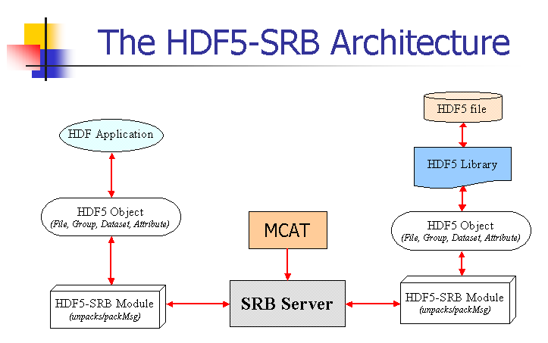

4.2 Project progress
1) Present the HDF5-SRB model at tech. seminar on February 24, 2005
2) Compile and install test SRB server, March 2005
3) Send prototype of APIs to SDSC, March 2005.
4) Implement first round of HDF5 structure to represent HDF5 objects, March 2005
5) SDSC finished first round of the packMsg()/unpackMsg() function on April 11, 2005
6) Successfully tested the client-server model: client api → packMsg()/unpackMsg() → SRB server → HDF5 Object → HDF5 library.
7) Scheduled to present HDF5/SRB project on the AccessGrid/WebCast on May 3, 2005

5. Proposed Future Work
5.1 HDFView
1) Support OPeNDAP server access: access remote files supported by OPeNDAP server from HDFView. This will require to write OPeNDAP-HDF object layer that translates OPeNDAP objects into HDF object in Java.

2) support dimension scales and GEO locations.

5.2 HDF-SRB
1) integrate the HDF5-SRB model into SRB
2) write a HDF5-SRB client application
3) test and release

